**ABHISHEK SHARMA**

**CS 2ND YEAR**

**SECTION : “I”**

**ROLL NO.: 01**

**ENROLLMENT NO.: 12019009001127**

**PRE PLACEMENT CLASS**

**ASSIGNMENT SOLUTION IN Python LANGUAGE**

**DATE : 12.11.2020**

**Q1. Arrays and find the no. of elements in that Array.**

**Code:**

# problem 1 : element count

test = int(input())

for i in range (0,test):

len = int(input())

array = input().split(" ")

array.sort()

m = 0

for j in range (0,len):

if (m!=int(array[j])):

x = array.count(array[j])

print ("{} {}".format(array[j], x))

m = int(array[j])

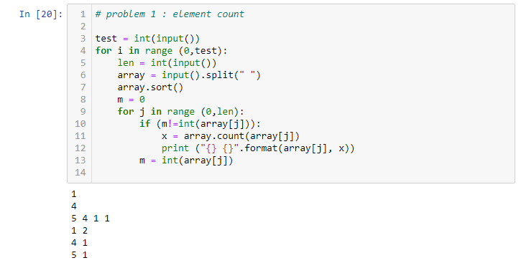

**Q2. Sayan and his race event.**

**Code:**

test = int(input())

for i in range (0,test):

count = input().split(" ")

total = int(count[0])

check = int(count[1])

c = 0

s = 0

l = 0

for j in range (1,100):

check1 = check*j

if (check1<total):

t = 2*check1

s = s + t

elif (check1==total):

c = 3*total

break

elif (check1>total):

l = total

break

x = s + c + l

print(x)

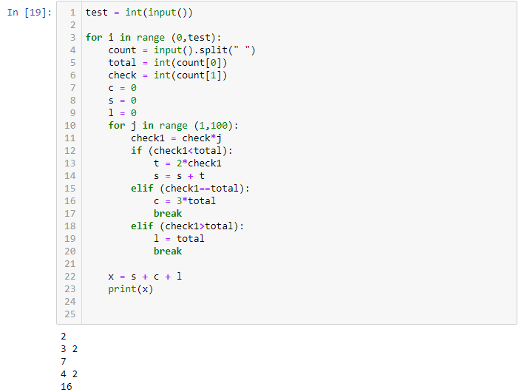

**Q3. Chef and Queries problem**

**Code :**

test = int(input())

for i in range (0,test):

task = input().split(" ")

q = input().split(" ")

p = int(task[0])

s = int(task[1])

k = 0

work = 0

count = 0

sum1 = 0

for j in range (0,p):

sum1 = sum1 + int(q[j])

while (1>0):

work = sum1 - s

sum1 = work

if (work<0):

print(k+1)

break

k = k + 1

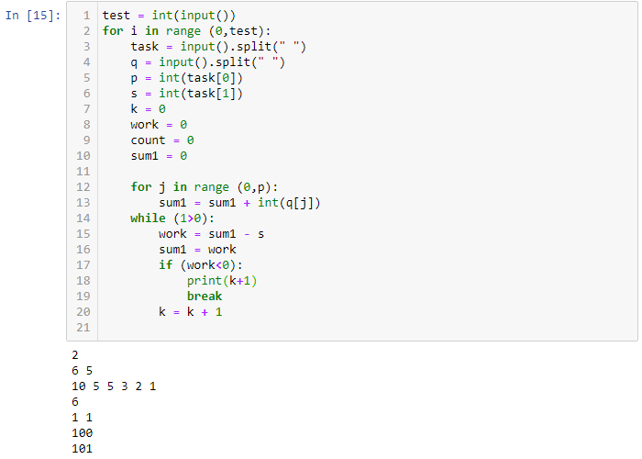

**Q4. Covid Run problem**

**Code:**

t = int(input())

while t:

t= t-1

n,k,x,y = [int(l) for l in input().split()]

count = [0]*n

while True:

if count[x]:

flag = 1

break

count[x] +=1

x = (x+k)%n

if count[y]:

flag = 2

break

if k==0 or k==n:

if x==y:

print("YES")

else:

print("NO")

elif flag==2:

print("YES")

else:

print("NO")

